**ASSIGNMENT COVER SHEET**

For use with online submission of assignments

Please complete all of the following details and then make this sheet the **first page of each file of your assignment – do not send it as a separate document.**

Your assignments must be submitted as either **Word documents, text documents with .rtf extension or as .pdf documents**. If you wish tosubmit in any other file format please discuss this with your lecturer well before theassignment submission date.

|  |  |
| --- | --- |
| Student Name: | **Guowei Cui** |
| Student ID No.: | **202100408073** |
| Unit Name: | ISYS3001 Managing Software Development |
| Unit Code: | ISYS3001 |
| Tutor’s name: | **Zhenjin Huang** |
| Assignment No.: | Assessment 2 |
| Assignment Title: | Practical Skills |
| Due date: | 18 September 2023 11:59 PM (AEST) |
| Date submitted: | **24/9/2023** |

Declaration:

*I have read and understand the Rules Relating to Awards ([Rule 3 Section 18 – Academic Misconduct Including Plagiarism](http://policies.scu.edu.au/view.current.php?id=00140" \l "s18)) as contained in the SCU Policy Library.   
I understand the penalties that apply for plagiarism and agree to be bound by these rules. The work I am submitting electronically is entirely my own work.*

|  |  |
| --- | --- |
| Signed: | Guowei Cui |
| (please type your name) |  |
| Date: | 24/9/2023 |

1. Segregate the Teach Fay/Term4-Assessment2 storage pool and integrate it into my shared storage pool

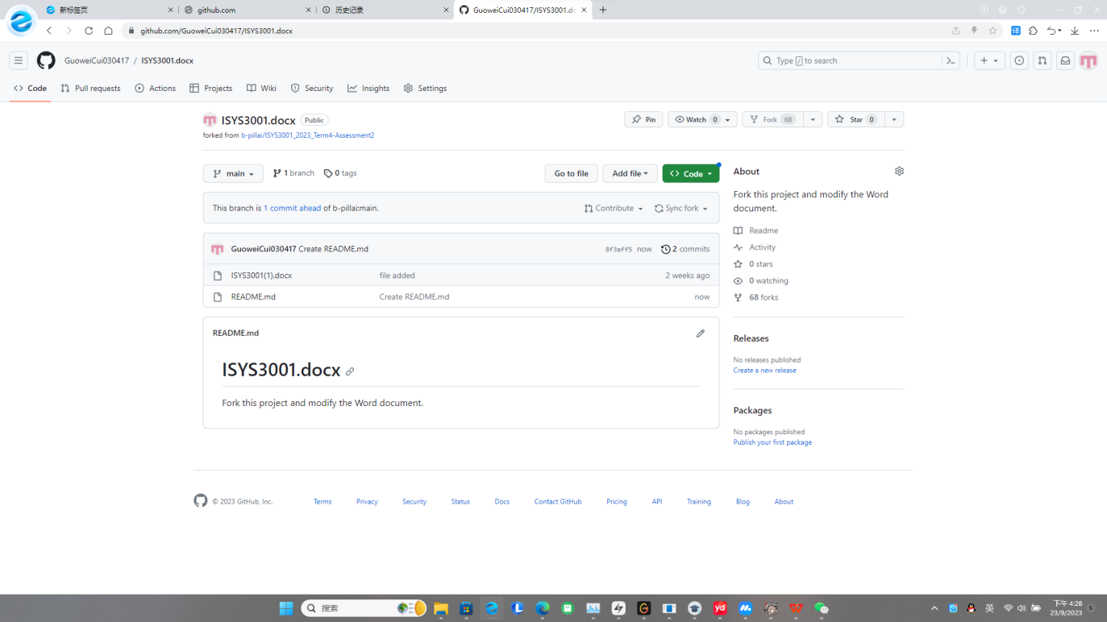

2.Create the page once the pull request has been completed.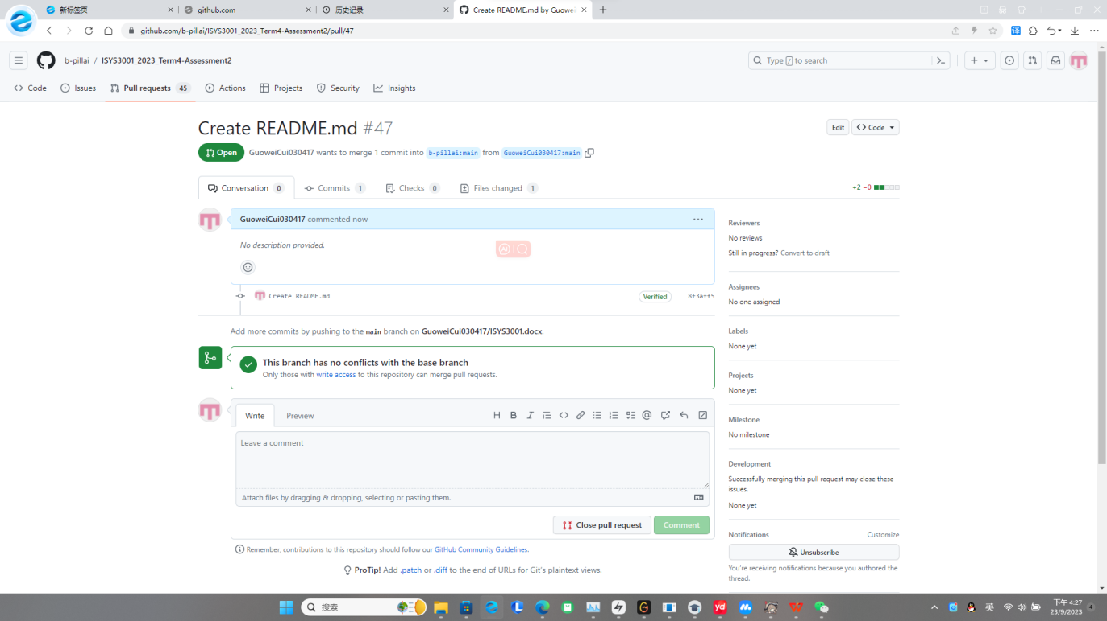

Company management of system configuration

Recommendations for the above process are detailed as follows:

1. Introduce change management:

*  Establish a change Management team to coordinate and drive the implementation of change management.
*  Establish a change management process, including the collection, evaluation and approval of change requests.
*  promotes cross-team communication and collaboration, ensuring that the development team is aware of deployment goals and changes through regular meetings, knowledge sharing, etc.

2. Use version management tools:

*  Select the version management tool suitable for the team requirements, such as Git and SVN, and provide team training and guidance.
*  mandates developers to use version management tools for code changes, commits, and merges, ensuring that code history is traceable and conflict resolution feasible.
*  Configure appropriate branching policies to facilitate parallel development and collaboration among team members.

3. Optimize the system construction process:

*  Introduces continuous integration and continuous delivery (CI/CD) methods to establish processes that automate build, test, and deployment.
*  Configure automated checks for code quality and unit tests, and ensure timely execution of integration tests.
*  manages versions of build tools and dependency libraries to avoid build environment inconsistencies and dependency conflicts.

4. Establish an effective release management process:

*  Establish a release management team, define the person in charge of release and related roles, and define their responsibilities and authority.
*  Pre-release testing, including functional testing, performance testing, and security verification, is performed before product deployment to ensure product quality and consistency.
*  Establish a rollback plan and backup policy for emergencies and release failures.

In short, by introducing change management, version management tools, optimizing the system build process, and establishing an effective release management process, software development companies can improve product deployment consistency, reduce integration issues, and reduce project delays.

Request for comment

Company introduction

Business Buzz Australia (ABB) seeks an integrated system to enhance operations, including customer relationship management, procurement history tracking, and equipment maintenance management. The system must be powerful, scalable, and able to support future expansion.

To find the ideal solution, ABB issued a Request for Proposals (RFP) to invite potential suppliers. The RFP seeks information on functionality, reliability, performance, security, support, and cost of the integrated system. ABB aims to attract vendors offering robust and reliable systems.

This integrated system will facilitate effective customer relationship management, purchase history tracking, and equipment maintenance. It requires a user-friendly interface to enhance employee efficiency. Scalability is vital to accommodate future needs and changing requirements.

Through the RFP, ABB aims to evaluate supplier capabilities and solutions, selecting the best partner for their integrated system goals. Following selection, ABB will collaborate with suppliers to implement and test the system, ensuring smooth deployment and alignment with business needs. This process aims to enhance operational efficiency, optimize customer relationship management, and provide reliable repair services.Through the request for proposals, ABB hopes to evaluate supplier capabilities and solutions and select the most suitable partner to achieve their integrated system goals. After the selection is complete, ABB will work with suppliers to implement and test the system to ensure it can be deployed smoothly and meet their business needs. The entire process is designed to help ABB improve operational efficiency, optimize customer relationship management, and provide reliable repair services.

Task object

Our goal was to create an automated and self-healing integrated system for ABB's four subsidiaries. It includes:

1.Customer Relationship Management (CRM): centrally manages customer information, improving customer satisfaction and loyalty.

2.Procurement history tracking: tracks supplier information and optimizes supply chain management.

3.Equipment maintenance management: records maintenance requests and improves response time and service quality.

4.Automation and self-repair: detects and resolves system failures, improving reliability and reducing downtime.

These systems enable data sharing and process coordination across subsidiaries, enhancing efficiency and decision-making. Automation and self-healing features reduce repair time and costs, improving customer service and productivity.

Mission Content

1. Customer Relationship Database: Establish a customer relationship database that contains information about purchased products and services, as well as information related to equipment maintenance (including customer details, purchase history, problem reports, repair work details, etc.).

2.Digital Marketing System: Establish a system that allows for digital marketing using email, social media, and other modern marketing technologies. The system will draw on details from the customer relationship database while allowing the entry of details of other potential customers into existing Australian Business Buzz websites (not included in the scope of this RFP).

1. Inventory management system: Establish an inventory management system that includes products for sale, parts needed for maintenance, and automatic ordering by wholesalers. The system needs to support inventory management at individual locations and be able to find products and parts at other ABB locations when needed.

4.Reporting and Decision Support: Provides a capability to report all of the above to management (which may be located anywhere) and to support inventory ordering, employee hiring, and other management decisions.

Task development schedule

1.2023/9/24-2023/9/27

To find the problem and get approval, the programmer needs to find the problem and improve it in a timely manner

2.2023/9/28-2023/9/29

Project planning and monitoring:

In the project, we did UML modeling, including creating flowcharts and writing visual documentation.

3.2023/9/29-2023/10/2

Accurately identify the development environment of the system, and certify the feasibility of the system development, and document its functional development

4.2023/10/3-2023/10/5

Editing system needed accessories:

Use UML to model the project, including drawing ERD diagrams, use case diagrams, activity diagrams, and component diagrams, and writing executable pseudo-code to implement algorithms.

5.2023/10/6-2023/10/9

In an integrated system, the individual subsystems are programmed and built using high-level languages, utilizing algorithms that are already designed. At the same time, individual subsystems can be programmed using TDD (Test Driven Development).

6.2023/10/10-2023/10/20

Test and integrate system components:

First, unit testing, then integration of each unit, interface testing and system testing of each subsystem, and finally integration of each subsystem into an integrated system for broader system testing, then release testing and user testing.

7.2023/10/20-2023/10/26

Deliver tasks and update and maintain them persistently

If a vendor is interested in your proposal, propose a solution to the problem it raises

1.System description: Provide a clear description of the system you need, including its functions, technical requirements, and integration needs.

2.Evaluation method: Explain how proposals will be evaluated, including criteria, process, and weight allocation. Consider providing a score sheet or guide for vendors to follow.

3.Questions: Inform vendors that they can ask questions to better understand and provide accurate information. Specify the deadline and response method.

4.Proposal value: Clearly communicate the value of your proposal to vendors, highlighting potential business opportunities, project scale, and long-term relationship benefits.

Additional details may include:

5.Contact information: Provide contact details for RFP submission and questions, including name, title, phone, and email. State availability and response time.

6.ABB internal information: Include relevant ABB details like project code and internal classification number to align with internal processes.

Ensure the RFP is concise, clear, and provides sufficient information for vendors to understand your requirements and offer accurate recommendations.